PURCHASE
KS1 – 2003 Paper 1
1.
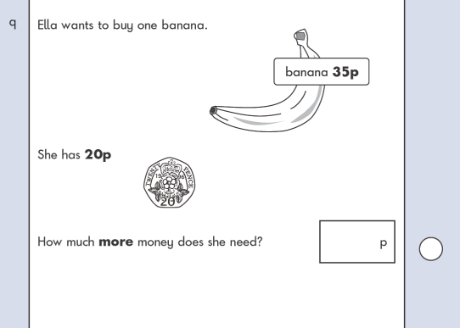
KS1 – 2007 Paper 1
2.

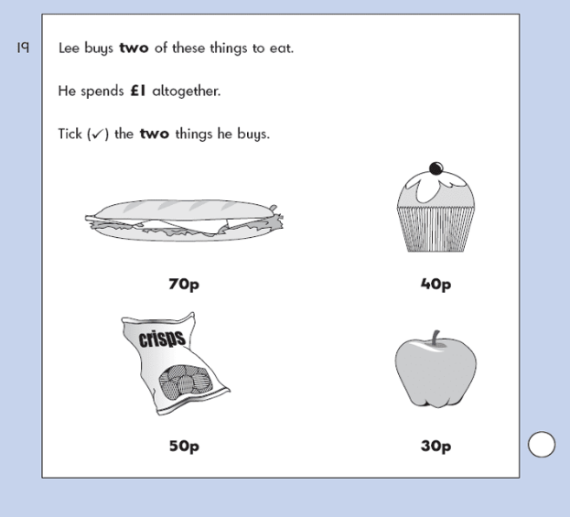
KS1 – 2007 Paper 2
3.

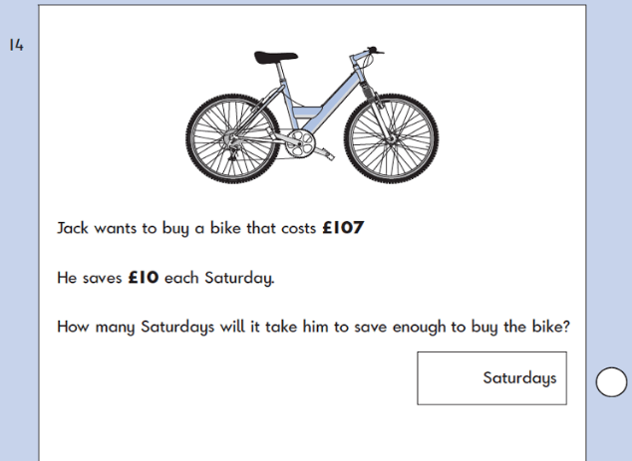
KS1 – 2016 Paper - Reasoning
4.

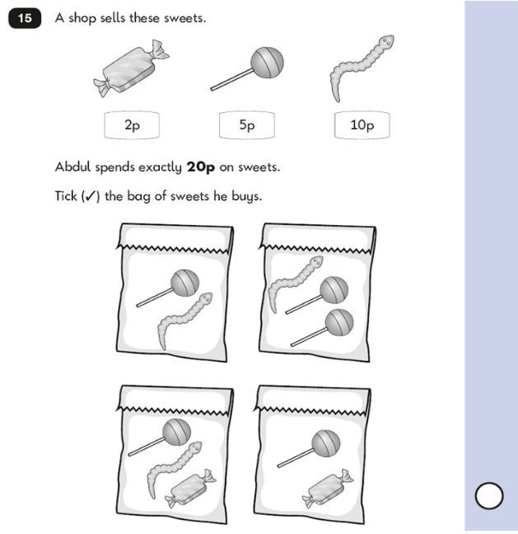
KS1 – 2016 Paper – Reasoning (Second)
5.

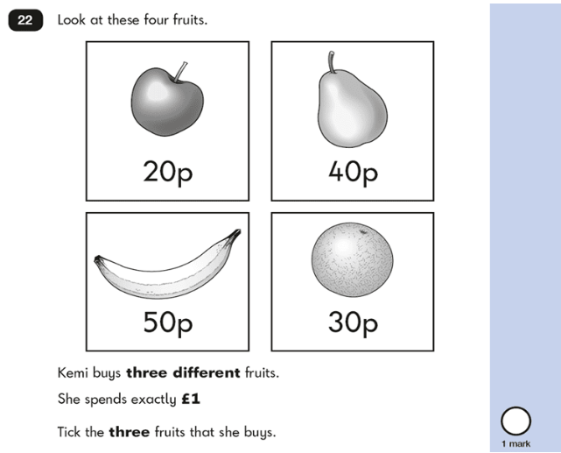
KS1 – 2017 Paper – Reasoning
6.
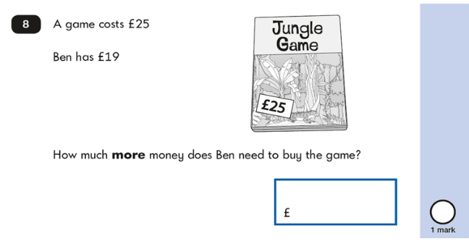
KS1 – 2018 Paper – Reasoning
7.
